How to Prepare the Manuscript in a Camera-Ready Form for the Electroporation based Technologies and Treatments postgraduate course

Peter Kramar¹, Matej Kranjc¹, Damijan Miklavcic¹, Lluis M. Mir²; ¹ Faculty of Electrical Engineering, University of Ljubljana, Trzaska 25, SI-1000 Ljubljana, SLOVENIA ² CNRS UMR 8121, Institut Gustave-Roussy, 39,Rue Camille Desmoulins, F-94805 Villejuif Cédex, FRANCE

INTRODUCTION
This document contains information for the preparation of manuscripts in camera-ready form to be submitted for the Electroporation based Technologies and Treatments postgraduate course. Manuscripts must be written according to the layout and instructions given in this document. You can also use an MS Word file provided at www.ebtt.org as a template for your manuscript.

PAGE LAYOUT
The maximum length of paper is one A4 page. Leave 2.5 cm margins on the top and the bottom of the page and 2 cm margin on the left as shown on this page. Text must be arranged in two columns (width 8.5 cm, 0.5 cm in between) thus leaving a 1.5 cm margin on the right. The rectangle around this text only indicates the active text area on one page.
Title should be centred at the top of the page, using the whole width of the page. The title should not exceed two lines. Full names of authors, and their affiliations and addresses should be left aligned using the whole width of the page. Mark the affiliation of each author clearly.

FORMAT
Use Times New Roman font throughout your manuscript. For different parts of the manuscript use font sizes and styles as given in Table 1.

Table 1: Font sizes and styles to be used in manuscripts.
 | font size | font style
title | 14 pt | bold
authors | 12 pt | normal
affiliations | 12 pt | italic
headings | 10 pt | BOLD CAPS.
normal text | 10 pt | normal

Use single line spacing for normal text. Start each paragraph with a 0.5 cm indentation. Do not add blank lines between paragraphs but do add one blank line before after each heading. Use only one level of headings and do not indent them.
If possible use standard structure for your manuscript. Start it with a short introduction followed by a description of the methods used. Specific results should be presented and main conclusions should be outlined.

RESULTS AND FIGURES
Number your figures (Figure 1) and/or tables (Table 1) consecutively. Do not indent figure and table captions. If you use equations, number them consecutively too.
The tables must be inserted in text. Include figures and equations in your camera-ready manuscript. Figures may be fit across both columns if necessary. Use only figures in grayscale!

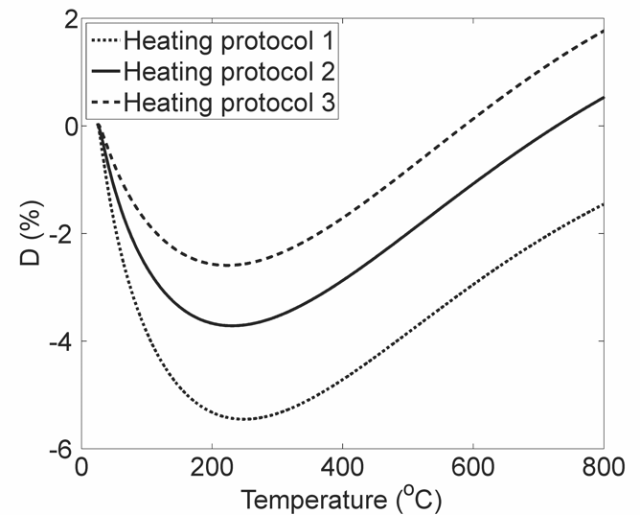
Figure 1: Example figure in grayscale.

REFERENCES
References must be numbered in square brackets in the order of their first citation in the text [1]. A full list of references should be given at the end of the paper using the IEEE format as shown here [2,3].

[1] A.B. Author, S. More and S. Else, "Title of the paper," Journal Name, vol. 77, pp. 88-99, 1999.
[2] C.D. Writer, Book Title. New York: Cliffhanger, 1970.
[3] E. Author, "Title of paper in a book," in Proceedings of the ICBEM. Tampere, Ragnar Granit Foundation, 1996, pp. 77-80.

